**4021 Determination of Coefficient of Linear Thermal Expansion for Glass**

This method applies to determine the coefficient of linear thermal expansion for glass containers similar to the glass reference material in coefficient of linear thermal expansion (National pharmaceutical reference material, hereinafter referred to as glass reference material).

**Determination Principle:** The glass reference materials and the sample are stacked and burned together and drawn into a filament. The filament will bend if the linear thermal expansion coefficients of the two kinds of glasses are different. The linear thermal expansion coefficient of sample can be determined based on the bending direction and degree of the filament.

**Instruments**

Heating device: Blowtorch use coal gas, liquefied petroleum gas, or natural gas as the gas source and use compressed air or oxygen to support combustion.

Special Clamps: Iron or steel materials, recommended size: 200 mm long, 20 mm wide, 1 mm thick. To avoid scalding your hand, two insulation plates shall be set at 100 mm from the handle end, as shown in Figure 1.

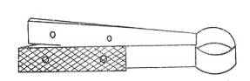

Figure Special clamps

Tweezers: Use to draw glass filaments.

Micrometer (accuracy: not less than 0.01 mm) and the support.

Scaleplate for measuring: It is composed of a glass plate and a glass mirror, both with a size of 250 mm × 300 mm. The mirror is affixed with calibrated coordinate paper marked with the horizontal and vertical axes. Around two points at a lateral distance of 200 mm and on both sides of the vertical line. The 3 mm graph paper is cut to expose the mirror. The 60 mm coordinate paper at the upper and lower parts are cut on both sides of the vertical line, as illustrated in Figure 2.

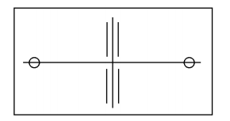

Figure Scaleplate for measuring

[**Determination**](javascript:;)**:** Burn one end of the glass reference material until softened and clamp it flat with a special clamp (as shown in Figure 1). Burn again and stretch it for 20 mm-30 mm; Burn it until softened again, pull (cut) off the front tip to form a shovel shape of about 6 mm wide, 20 mm long and 1 mm thick.

Take a small piece of sample (there should be no glass defects affecting the results, such as stones, knots, bubbles, etc.), glue it to a pre-prepared glass rod, and make it into a shovel shape following the above procedures. The two shovel shapes are required to be generally in consistent in width and thickness. Overlap the two shovels and burn them together without glass defects such as bubbles. Burn off the end of the rod stained with the sample.

Draw the shovel-shaped glasses that burned together into a filament with a diameter of 0.10 mm- 0.14 mm and a length of no less than 300 mm. When drawing, keep hands parallel to prevent the glass filament from twisting. Cut off the glass filament after it cools down to observe and determine the bending direction of the filament. A total of 5-6 glass filaments can be drawn for each shovel for testing. The drawing process is ~~as~~ shown in Figure 3.

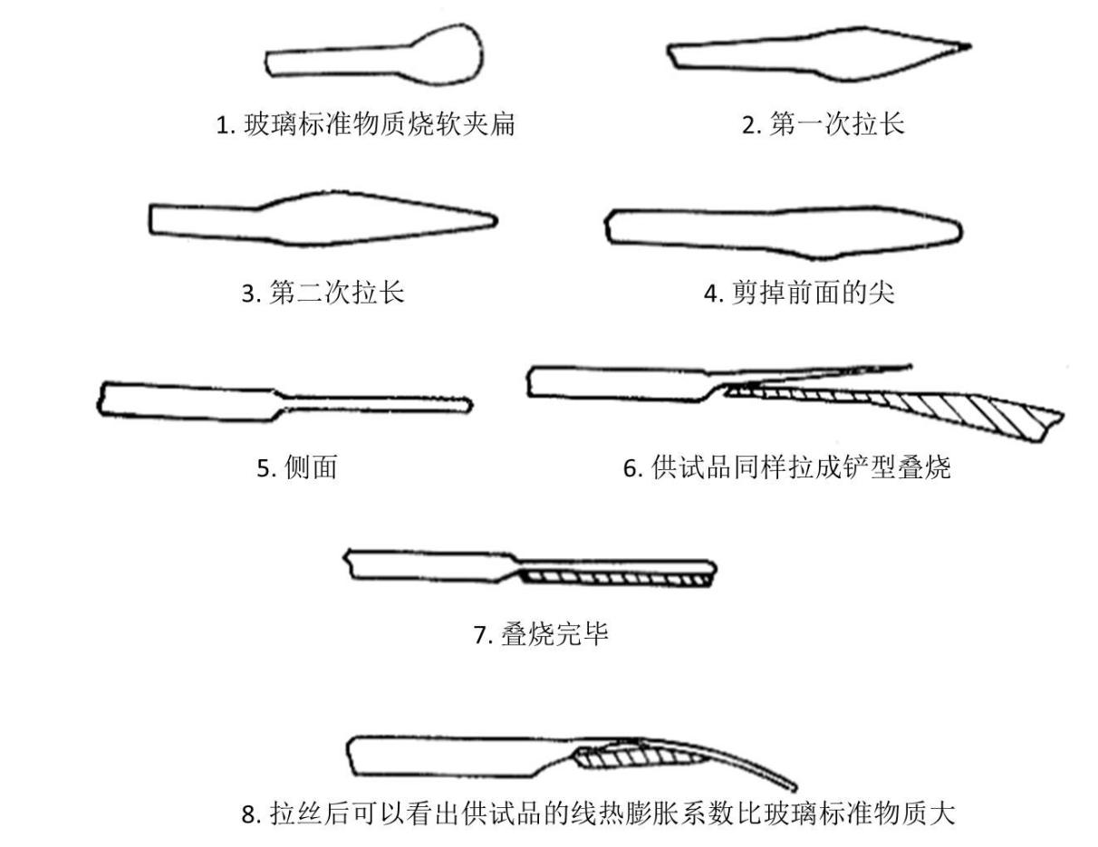

1. Burn one end of the glass reference material until softened and clamp it flat.
2. Stretch for the first time.
3. Stretch for the second time.
4. Cut off the front tip.
5. Side face
6. stretch the specimen to a shovel shape and overlap it to burn.
7. burn together.
8. After drawing to a filament, it can be seen that the linear thermal expansion coefficient of the sample is larger than that of the glass reference material.

Figure . Filament-drawing process

After the glass filament cools down, it will bend to the side with ~~a~~ larger expansion coefficient, and the degree of bending is proportional to the difference between the expansion coefficients of the sample and glass reference material. If it bends to the sample side, the *α*0 of the glass reference material plus ∆*α* is the linear thermal expansion coefficient of the sample. Otherwise, the *α*0 of the glass reference material minus ∆*α* is the linear thermal expansion coefficient of the sample. Select a glass filament of a diameter in 0.10 mm-0.14 mm with a micrometer and cut a section of 220 mm-230 mm long, read the diameters at the midpoint and both ends of the filament within the cut length. The difference between the filament diameters at the three measuring points shall not be greater than 0.02 mm. Take the average of the three filament diameters as *d*, in mm. If the glass filament has a high degree of bending, the cut length shall be longer. Put the cut glass filament on the glass plate in a free-falling shape, move the glass plate, so that the two points on the glass filament are aligned with the two points on the mirror coordinate paper that are 100 mm away from the midpoint. Read the bending height in the middle, *h*, in mm, accurate to 1 decimal place. Make three measurements of the bending height and take the average, as shown in Figure 4.

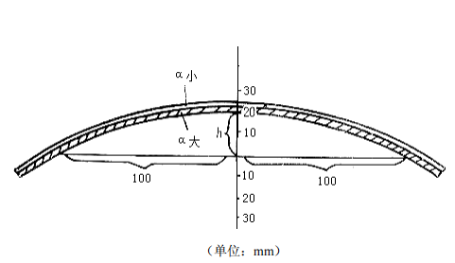

Material with a smaller α

Material with a larger α

(Unit: mm)

Figure . Measurement of filament bending

Coefficient of linear thermal expansion, *α*, can be calculated as follows:

*α*=*α0*±Δ*α*

*α* is the coefficient of linear thermal expansion of the sample;

*α*0 is the coefficient of linear thermal expansion of the glass reference material.

Δ*α* is the difference between the linear thermal expansion coefficients of the glass reference material and the sample.

When *h*≤20 mm, the difference between the coefficient of linear thermal expansion of the glass reference material and the sample, Δα, can be calculated as follows:

Δ*α*=0.14*hd*×10-6k-1

Where, *h* is the bending height, in mm；

*d* is the diameter of the filament, in mm.

When *h*>20 mm, the difference between the linear thermal expansion coefficients of the glass reference material and the sample, Δα, can be calculated as follows:



Where, *h* is the bending height, in mm；

*d* is the diameter of the filament, in mm.

**Result Representation.**

It is expressed as the arithmetic mean of the measurement results of three glass filaments, and the range of the three values shall be less than 0.02 × 10-6k-1. If the range of the three values does not meet the requirements, the test should be repeated.

Drafted by: National Institute for Food and Drug Control, Beijing Institute for Pharmaceutical Packaging Materials Inspection, Shandong Linuo Special Glass Co. Ltd. Contract number: 010-67095110